User Training Manual – Accounts Payable

Prepared for

**Technica International**

Version: **2.0**

Prepared by:

Mohanad Kamal

Mahmoud Karim

Table of Contents

01.

Introduction

02.

Accounts payable configuration

03.

Accounts payable processes

04.

Accounts payable reports

|  |
| --- |
| CONTENTS |

**INFO-SYS| TRAINING DOCUMENT** **01**

|  |
| --- |
| INTRODUCTION |

# Introduction

## Purpose

The purpose of this document is to provide guidance on managing vendor-related financial transactions through the Accounts Payable module in Microsoft Dynamics 365 Finance and Operations. It explains how to record, track, and control supplier invoices, payments, and credit notes to ensure accurate financial reporting and timely settlement of vendor obligations.

## Scope

This document covers the complete lifecycle of vendor transactions, including vendor creation and maintenance, purchase order invoicing, non-PO invoice processing, payment proposals, settlement, and vendor account reconciliation. It also covers reporting and inquiry functions that support accounts payable analysis.

# Accounts payable configuration

## Terms of payment

1. Use the Terms of payment form to define all the terms of payment that the company and its vendors use. You can also use a term of payment to calculate the due date based on the date of the invoice.
2. Accounts payable > Payment setup > Terms of payment.
3. Click New to create a new term of payment.
4. In the Terms of payment field, enter a code or a short name for the term of payment.
5. Enter a descriptive name for the term of payment in the Description field.
6. Click the Setup Fast Tab.
7. In the Payment method list, select the method to calculate the due date.
   * 1. Select Net and enter the number of days in the Days field.
     2. Or select COD in case of cash on delivery payment term.
8. Select the associated payment day in the payment day field.

## Method of payment

1. In the Methods of payment form, specify all the methods of payment the company uses to issue payments to its vendors. For each method of payment, enter information that states how payments should be posted.
2. Accounts payable > Payment setup > Method of payment.
3. Click New to create a new method of payment.
4. Enter a name for the new method of payment in the Method of payment field.
5. Enter a description of the method of payment in the Description field.
6. Click the General Fast Tab.
7. In the Posting area in the Account type list, select the type of offset account that is used for payments (Ledger or Bank)
8. Select the liquidity account for payment in the Payment account list.

## Vendor group

1. Vendor groupthat groups vendors with shared characteristics like payment terms, sales tax groups, or product categories.
2. Procurement and sourcing > Setup > Vendors > Vendor group.  
   A screenshot of a computer

   AI-generated content may be incorrect.
3. Click New, to create new vendor group.
4. In the vendor group field, enter the code for the vendor group.
5. In the Description field, enter the vendor group description.
6. Select the terms of payment for this group, default tax group and the time between invoice due date and payment date.

## Vendor posting profile

1. In Vendor posting profiles, the summary accounts are defined for vendors. Summary accounts are temporary accounts where all invoices are posted to and offset when the vendor is paid. Will assign a summary account to each group of vendors in each posting profile.
2. Accounts payable > Setup > Vendor posting profile.
3. Select the posting profile.
4. Click the Setup Tab.
5. Click Add
6. Select “Group” in the Account code field
7. In the Account/Group number field, Select the Vendor group to which the posting profile setup record relates.
8. In the summary account field, Select the account number of the ledger account that is used as the Vendor’s summary account for the Vendor group.

## Charges codes

1. The charges codes are used to specify the kind of charge and how the charge is debited and credited.
2. Accounts payable > Charges setup > Charges code.
3. Click New to create a new charge code.
4. Enter a unique identifier for the charge in the Charge code field.
5. Enter a short description of the charge in the Description field.
6. Use the Posting tab to specify how to automatically debit and credit the charge.
7. The following fields exist for both Debit and Credit field groups:
   * 1. Type: Determines responsibility for the charge. The options are as follows:
     2. Item: A unit charge is added to the item cost, for example, a landed cost.
     3. Ledger account: The charge is incurred internally.
     4. Customer/Vendor: The customer or vendor incurs the charge.
     5. Posting: Identifies a posting description. This field is required if the Type field is set to Ledger account.
     6. Account: Specifies the ledger account that must be debited or credited, when the Type field is set to Ledger account.

# Accounts payable processes

## Vendor creation

Path: *Procurement and sourcing > Vendors > All Vendors >* Click *New*

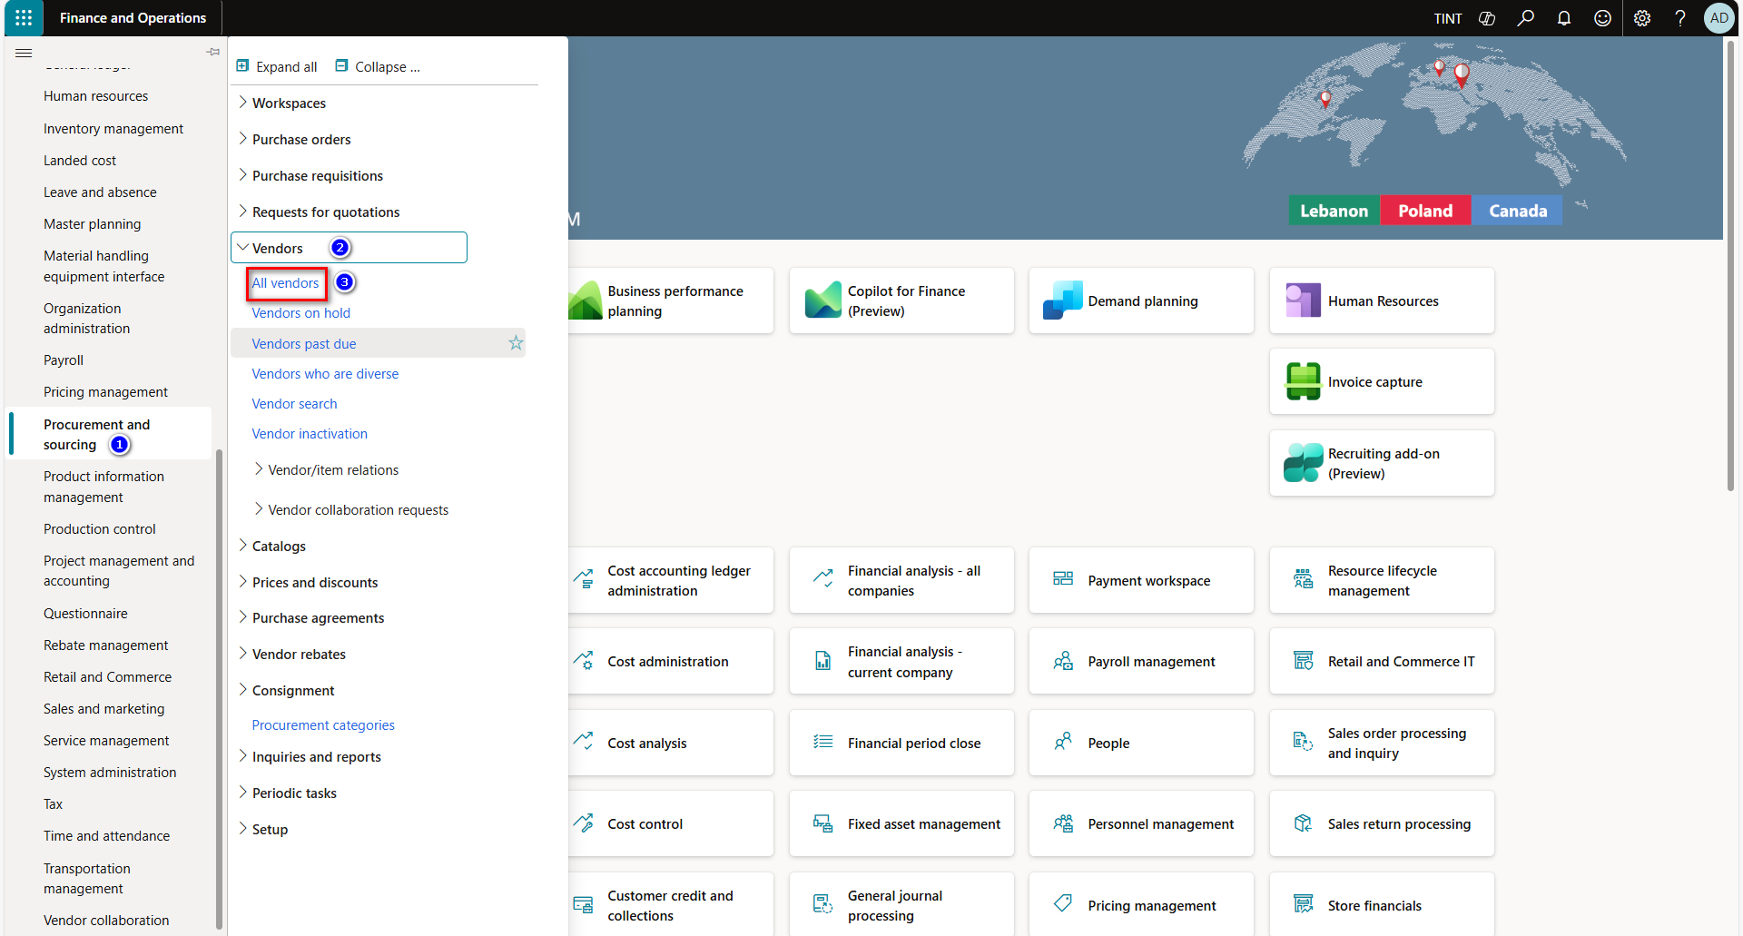

1. Type: Select whether the vendor is a person or an organization.
2. Enter vendor name in Name field.
3. Select and assign the vendor group in group field.
4. Select the language that is used for all external documents that are addressed to the selected vendor, such as purchase orders.
5. Enter vendor address.

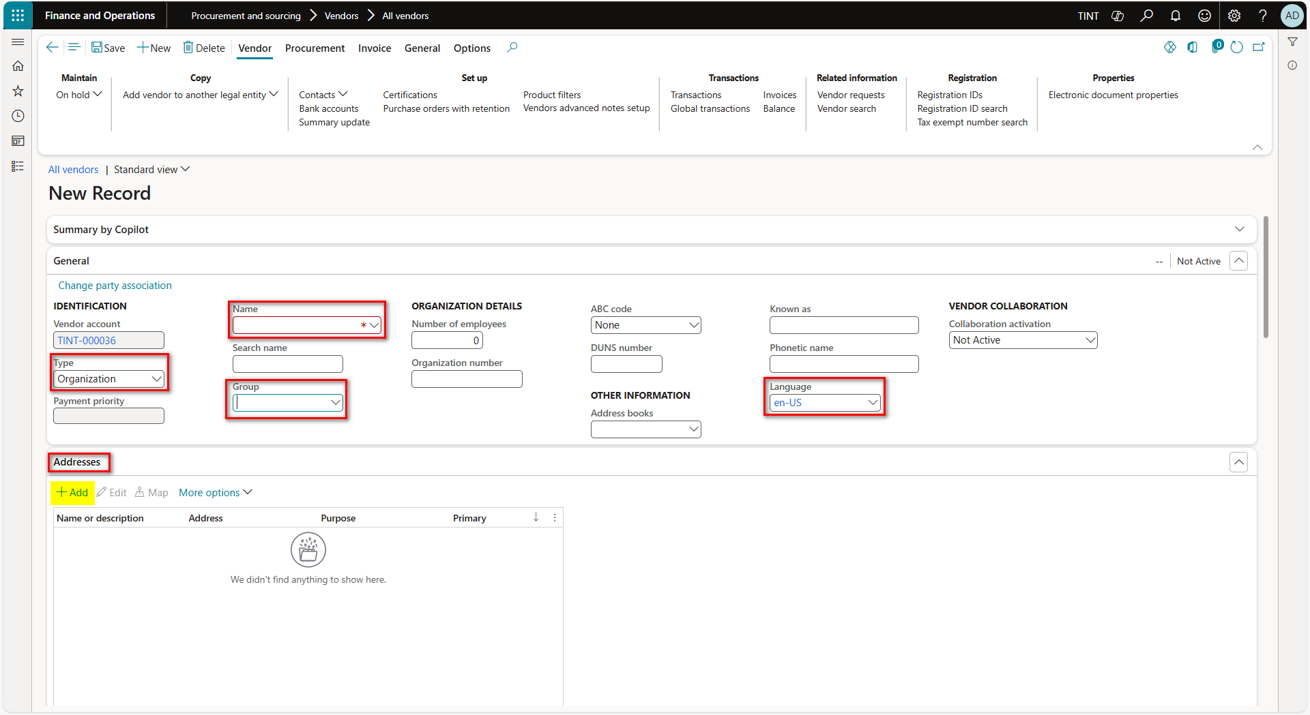

1. Add contact information for the company in case the vendor is an organization or the contact information for the person in case the vendor is a person

The contact type can be phone, email address, URL, telex, fax, Facebook, twitter and LinkedIn. The most used contact types are phone and email address.

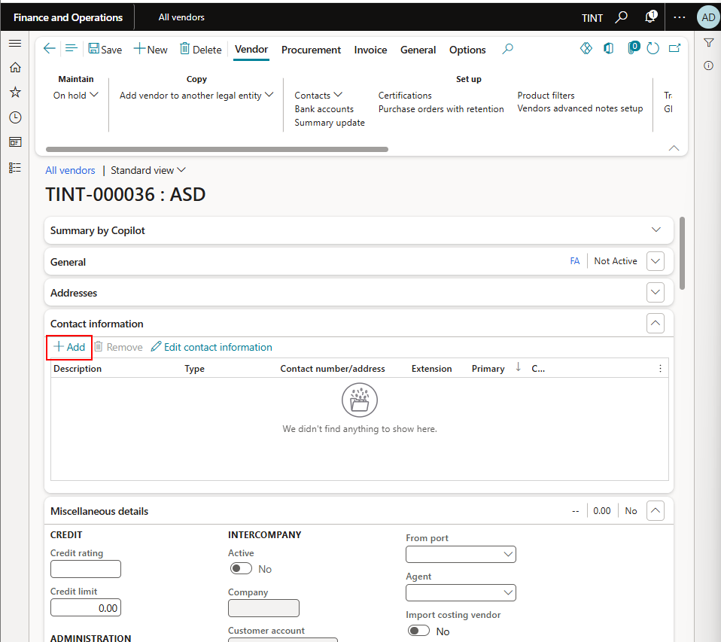

1. **Currency: The currency that is automatically entered on invoices to the selected vendor.**
2. **Sales tax group: Specify whether sales tax should be calculated on the invoice. It is recommended to enter it on the vendor but it can also be specified on the transaction level.**
3. **Select vendor delivery terms.**
4. **Select mode of delivery.**

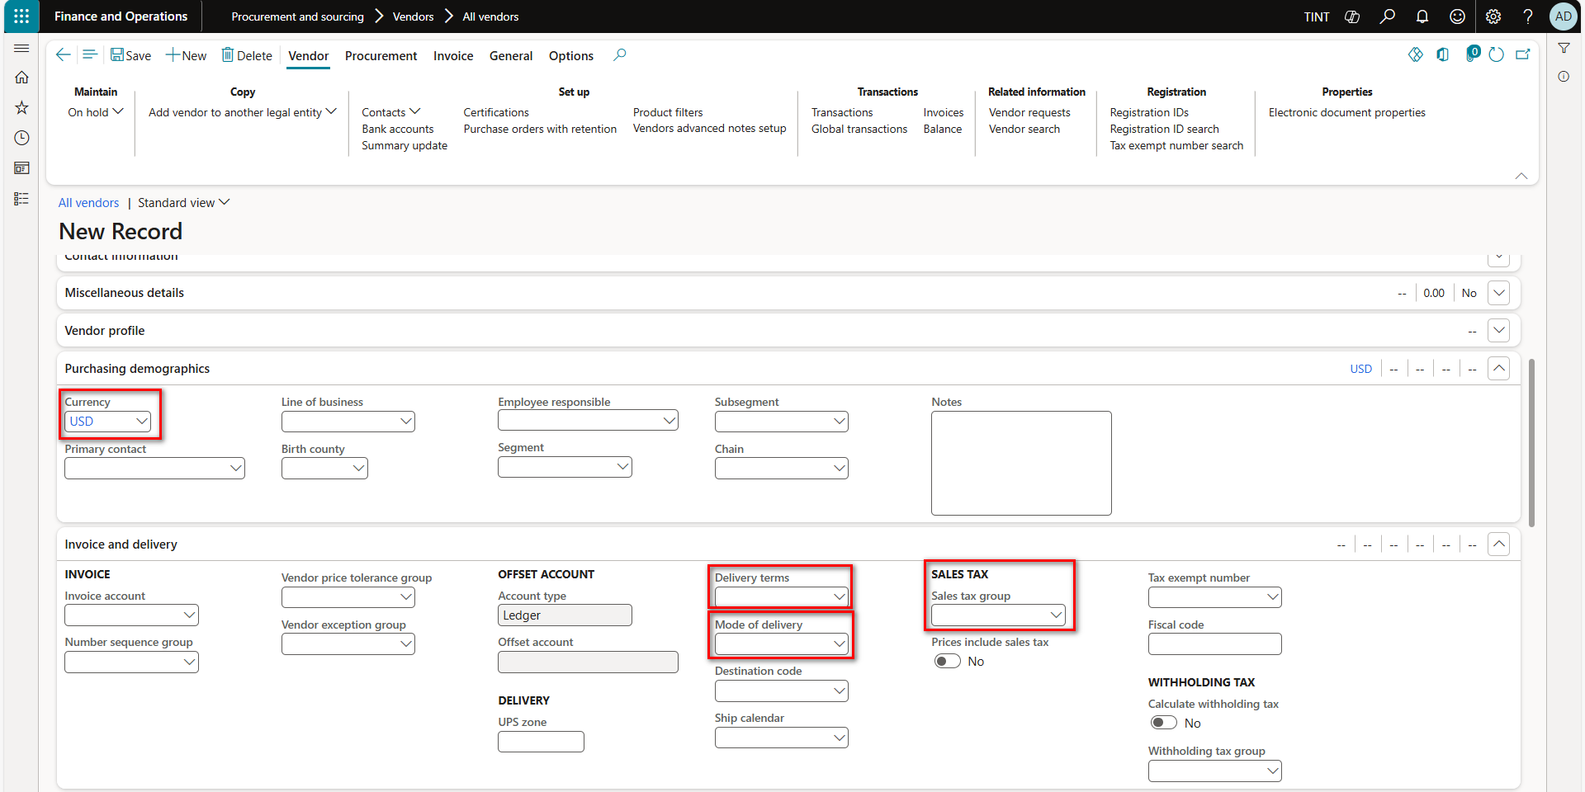

1. **Terms of payment: The terms of payment of the vendor.**
2. **Method of payment: The method of payment that is typically used for payments to the vendor.**

1. **Bank accounts**
   1. **To enter bank accounts, under vendor > setup > bank accounts, Click on New and specify the Bank Account Identifier, Name, bank group, Bank account number and IBAN number**.A screenshot of a computer

      AI-generated content may be incorrect.

1. Go back to the vendor details
2. For easier navigation and instead of going to the bank accounts table as mentioned in step 13, you can specify a preferred bank account for the vendor under Payment tab.

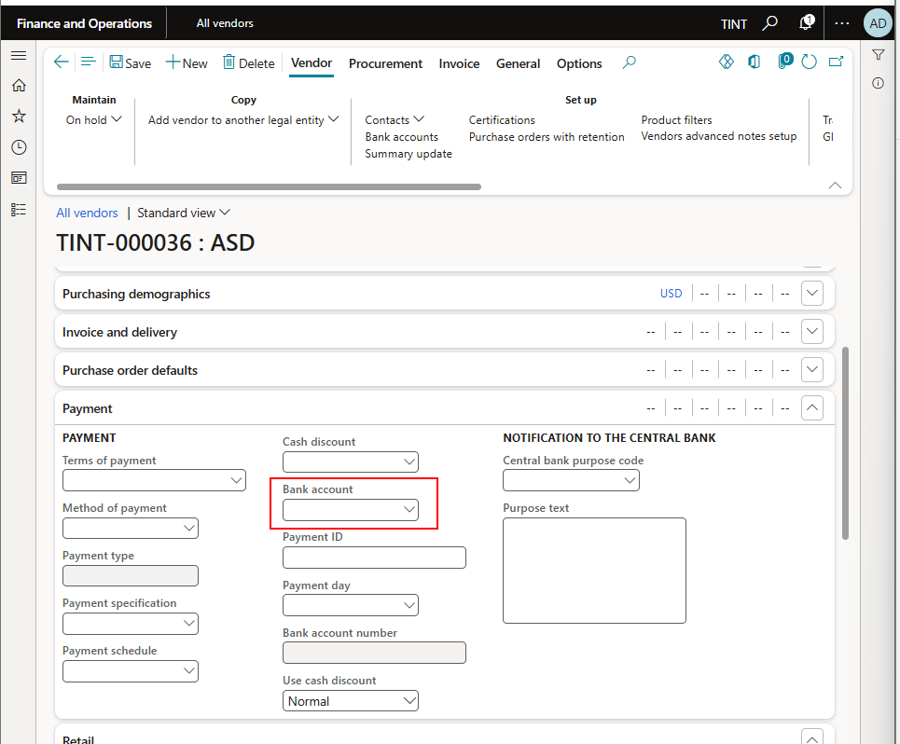

1. To add contact people, under vendor > setup > contacts. Select Add contacts.

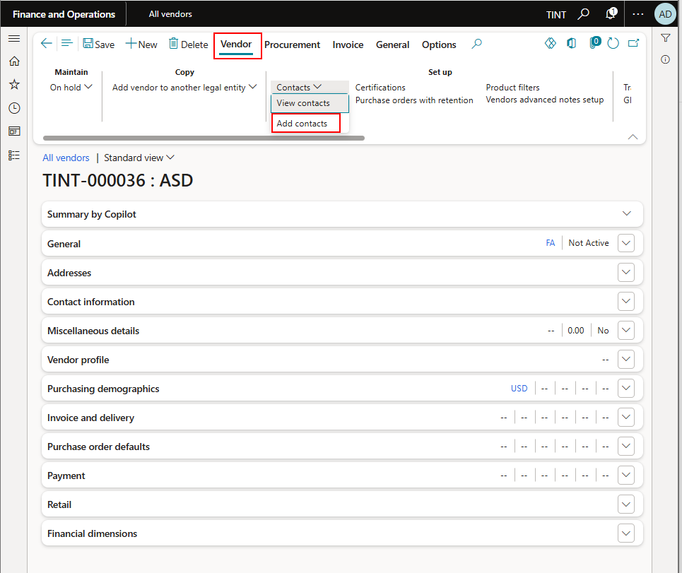

Specify the contact information such as the name, address, and contact information

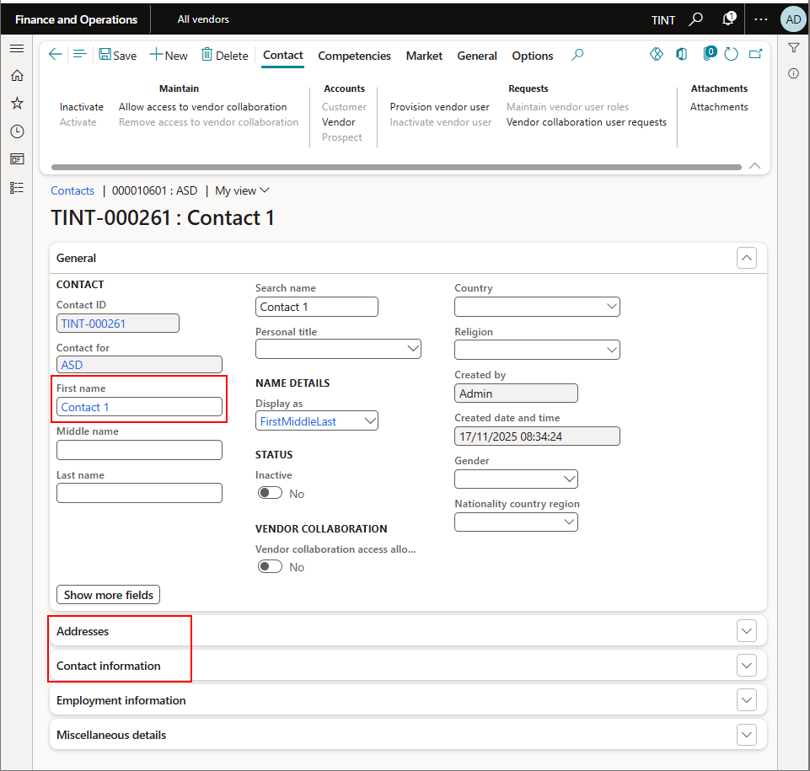

1. Go back to the vendor details
2. In case there is a preferred contact, specify the contact under purchasing demographics

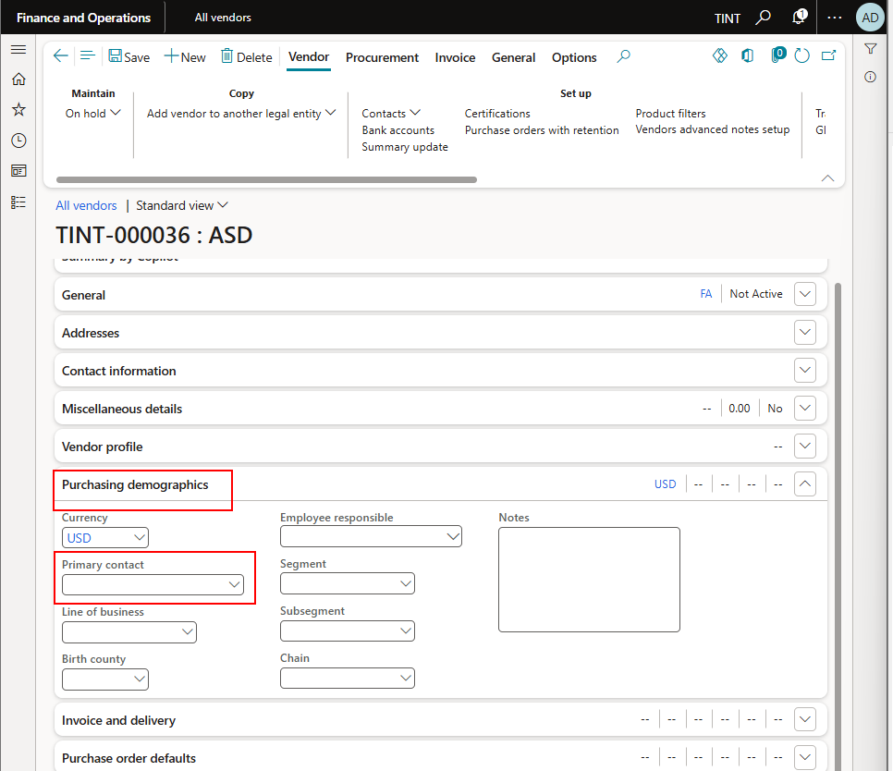

## Create vendor invoice journal

1. Accounts payable > Invoices > Invoice journal.
2. Click New to create a new invoice journal.
3. In the Name field, select the invoice journal related to invoice type.
4. Click lines to open journal lines.

1. Select the transaction date in the Date field.
2. Select the vendor account in the Account field.
3. Select invoice date in the Invoice date field.
4. Enter Invoice number in the Invoice field
5. Enter description for the transaction in Description field.
6. Enter the invoice amount in Credit field.
7. Select the currency in Currency field.
8. In the offset account type field, select the ledger, fixed asset or project depending on the invoice type.
9. In the offset account field, select the ledger account, project or fixed asset.
10. Select the Sales tax group associated to the vendor in the Sales tax group field.
11. Select the item sales tax group associated with the invoice items in the Item sales tax group field.
12. Click on financial dimensions and then click on account and update financial dimensions related to the vendor account.
13. Click ok to close the form.
14. Click on financial dimensions and then click on offset account and update financial dimensions related to the offset account (Financial dimensions might need to be updated in the Offset account field on the line directly if the offset account type field is set to ledger).
15. Click ok to close the form.
16. Click validate to validate the invoice journal lines.
17. In case there is a workflow defined, submit the invoice to the workflow. Otherwise, click Post to post the invoice journal lines.

## Invoicing a purchase order

1. Accounts payable > Purchase orders > All purchase orders.
2. Select the purchase order.

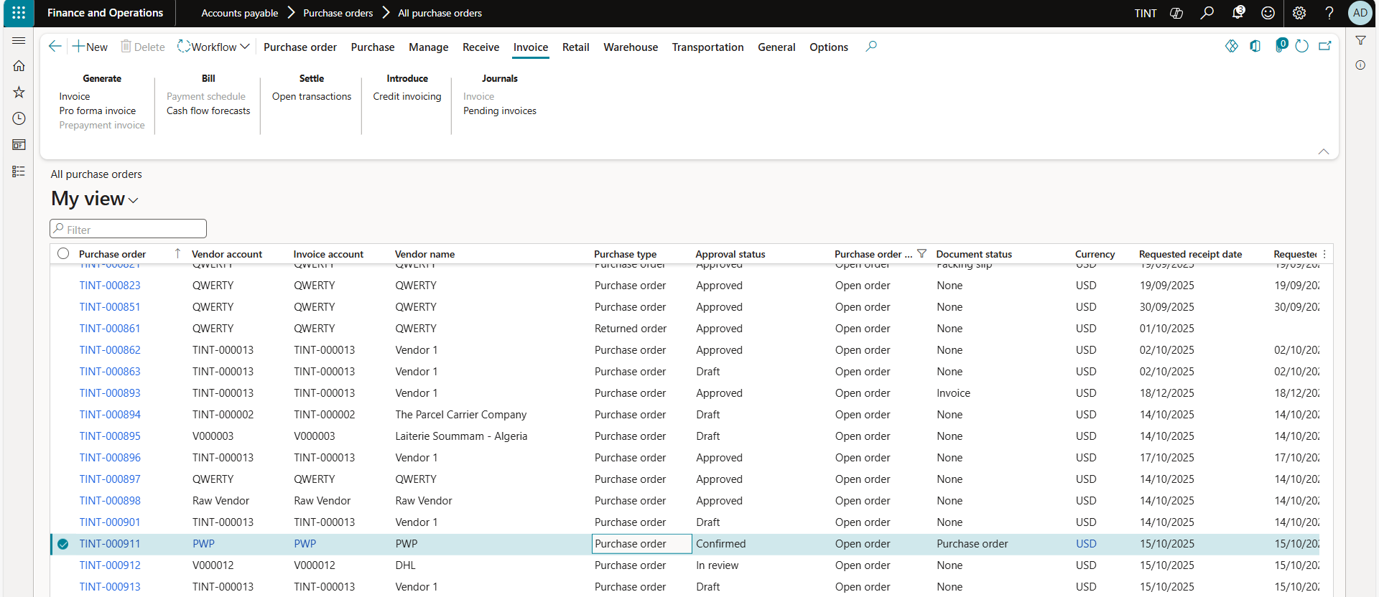

1. Click on Invoice Tab.
2. Click on Invoice in Generate group.
3. Use the following steps to open an already created purchase order invoice (Pending invoice)
4. Menu Path: (Accounts Payable > Invoices > Pending vendor invoices)

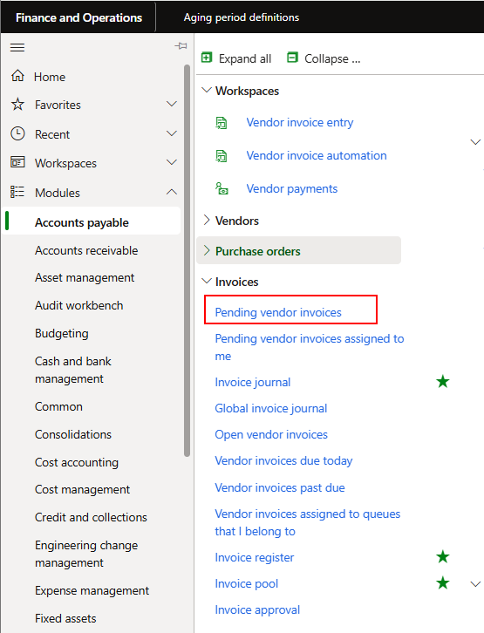

1. Select the invoice.
2. Click edit.
3. Use the following steps to post the created or opened invoice.

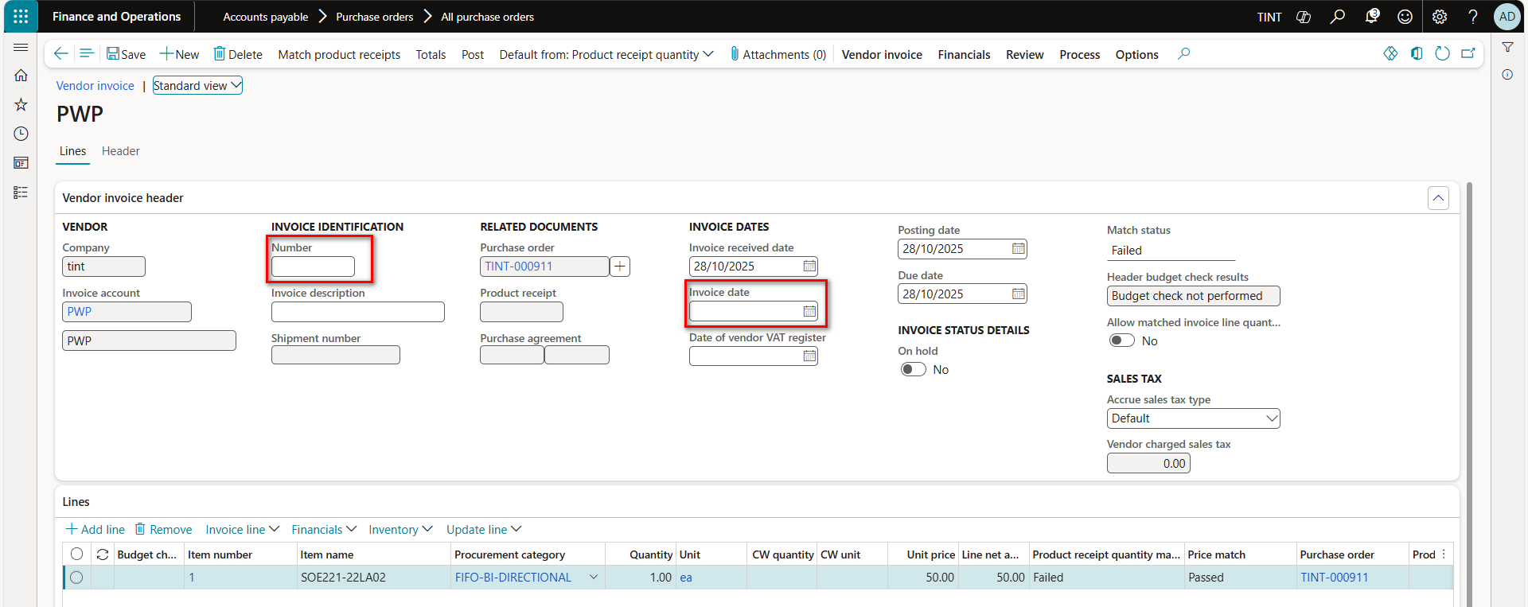

1. In the action pane, make sure that quantity is set to Product receipt quantity.
2. In the Vendor invoice header tab, update invoice data if needed.
3. In the Lines tab, update quantity or unit price if needed.
4. In the line details tab.

1. Select the Sales tax group associated to the vendor in the Sales tax group field.
2. Select the item sales tax group associated with the invoice line item in the Item sales tax group field.
3. In the action pane, click on Totals to check invoice totals before posting.
4. Click Post to post the invoice.

## Prepayments on the purchase order

To enter prepayment on the purchase order

Navigate to accounts payable > purchase orders > all purchase orders. Under purchase > prepay, select prepayment

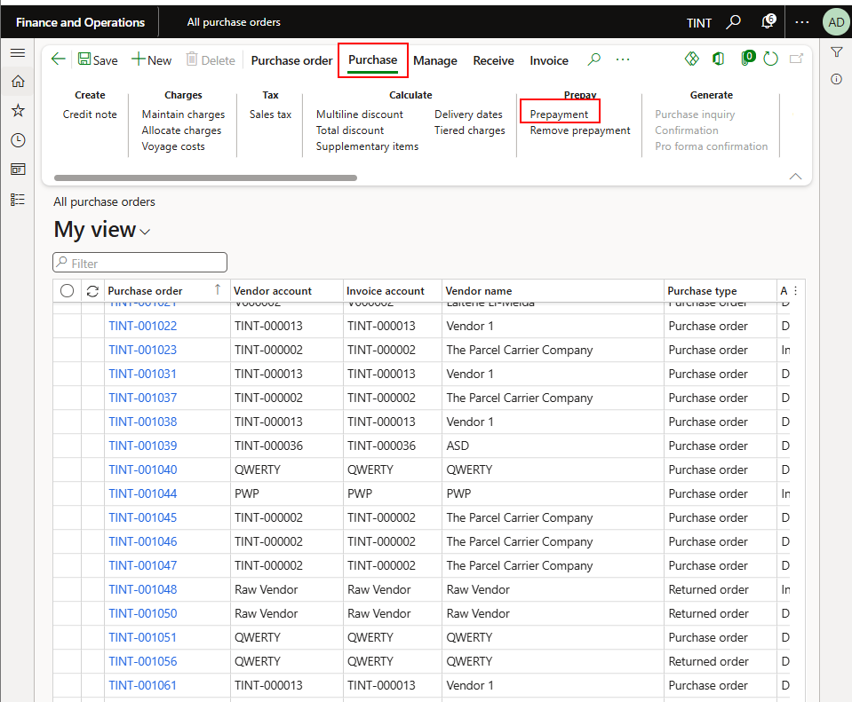

Enter prepayment information, it can be a fixed amount or a percentage.

Click save

Generate a prepayment invoice. Under invoice > generate > prepayment invoice

Select an invoice number and check the prepayment invoice details and click Post

## Vendor payments

1. Accounts payable > Payments > Vendor payment journal.
2. Click New to create a new payment journal.
3. In the Name field, select the payment journal related to the vendor payment’s method (Cash, Transfer, Check)

1. Click lines to open journal lines.

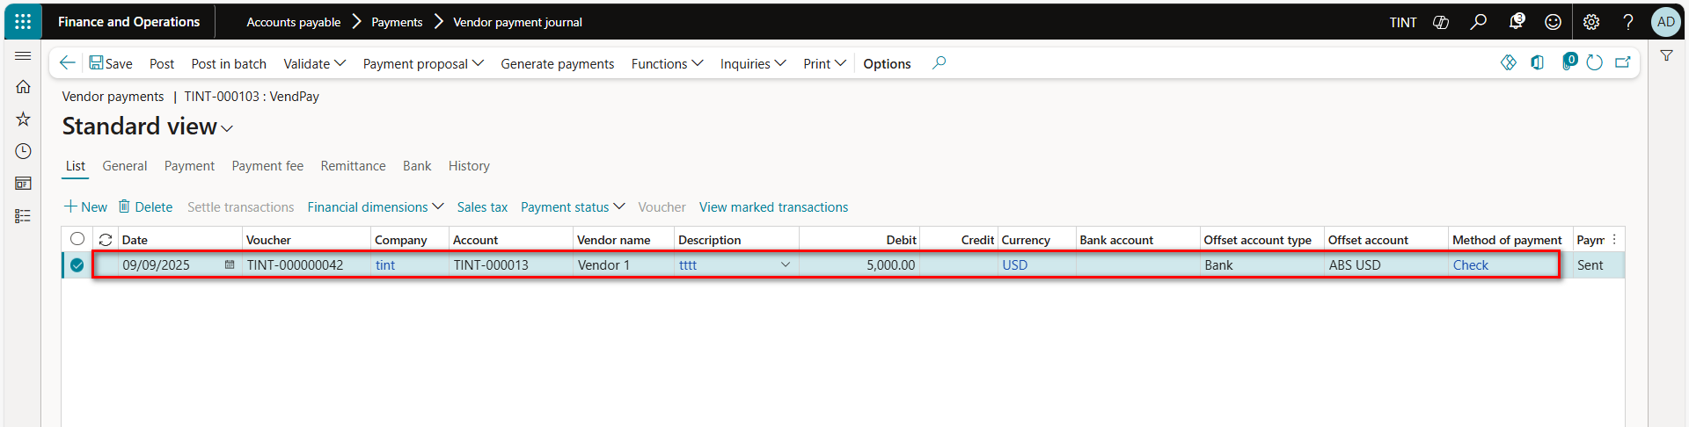

1. Select the transaction date in the Date field.
2. Select the vendor account in the Account field.
3. Enter description for the transaction in Description field.
4. Enter the payment amount in Debit field.
5. Select the currency in Currency field.
6. In the offset account type field, select the bank or ledger depending on the payment type.
7. In the offset account field, select the ledger account or bank account
8. Select the payment method in Method of payment field.
9. Click on financial dimensions and then click on account and update financial dimensions related to the vendor account.
10. Click ok to close the form.
11. Click on financial dimensions and then click on offset account and update financial dimensions related to the bank account (Financial dimensions might need to be updated in the Offset account field on the line directly if the offset account type field is set to ledger).
12. Click ok to close the form.
13. Click on settle transactions to link invoices related to this payment (Settlement can be done later from Vendor’s form directly if needed)
14. Mark invoices for settlement and update amount to settle if required for partial payment

1. Click OK

1. Click validate to validate the payment journal lines.
2. Click Post to post the payment journal lines.

## Settlement and undo settlement for vendor’s transactions

1. Accounts payable > Vendors > All vendors.

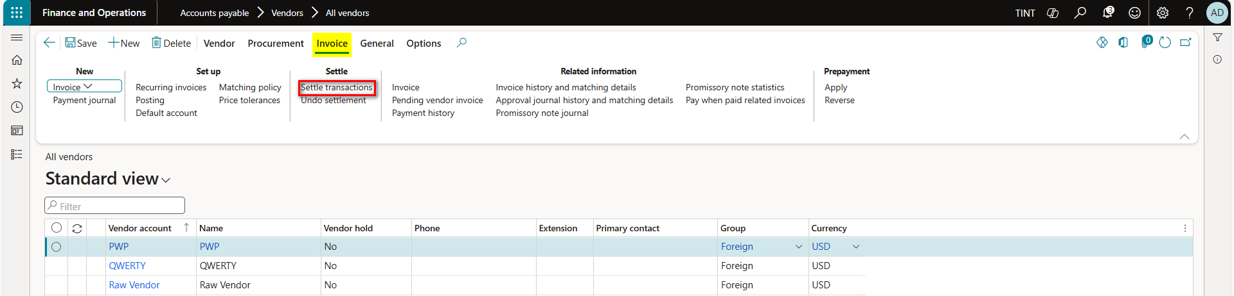

1. Click on Settle transactions to link posted payments to invoices.
2. Mark on the payment line and invoice line.
3. Click post.

1. Click on Undo settlement to reverse settlement between posted payment and invoice.
2. Mark on the payment line or invoice line.
3. Click Reverse.

## Reverse of vendor’s transactions

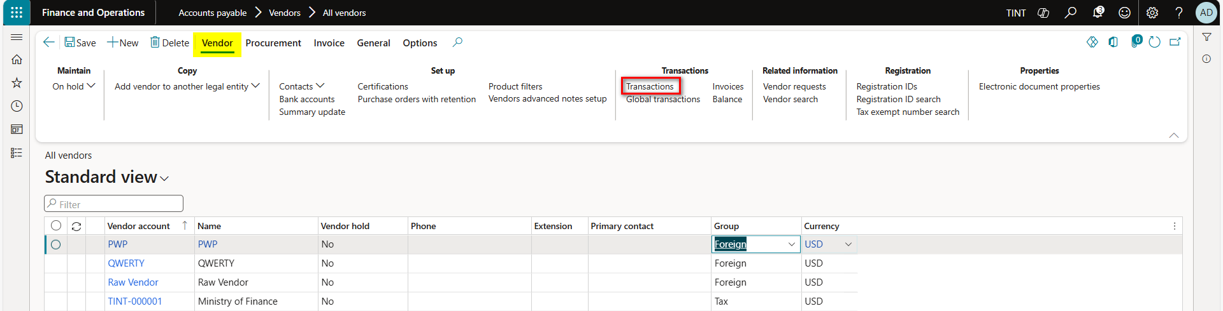

1. Click on Transactions.
2. Select the transaction needed to be reversed.
3. Click Reverse transaction for Vendor to ledger transaction.
4. Enter reversal date and click OK.

## Exchange rate modification

### Purchase order invoice:

* + - * 1. When invoicing the purchase order, it is still possible to modify the exchange rate in case the purchase order currency differs from the invoice currency.
        2. Navigate to the purchase order invoice (Accounts payable > Invoices > pending vendor invoices)
        3. Select the pending vendor invoice
        4. Under header > setup > currency. Switch the fixed rate to Yes and modify the exchange rate

* + - * 1. Post the invoice

### Vendor payment journal

* **Ensure to insert the “account type” and “Exchange rate” from the insert column functionality.**
* On the vendor payment journal, select the vendor account on the first line
* Select settle transaction and choose the related invoice to be paid.
* Add a second line, ensure that account type is bank. Enter the bank credit value and update the exchange rate on line level. (multiply the exchange rate by 100)

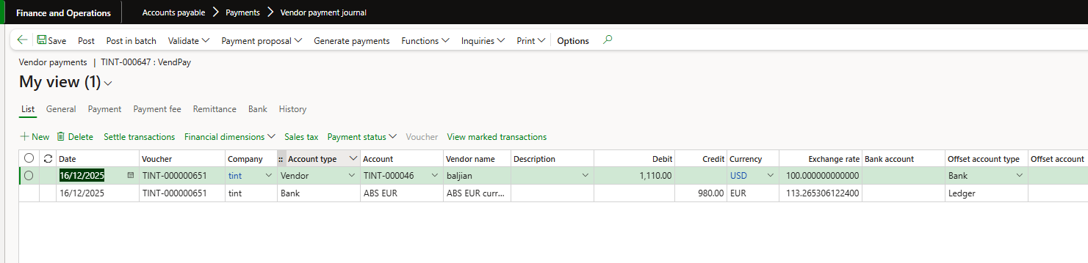

* **OR** Under general, select the currency and the exchange rate applicable without the multiplication calculation. Ensure to modify the LBP exchange rate as well to balance the transaction.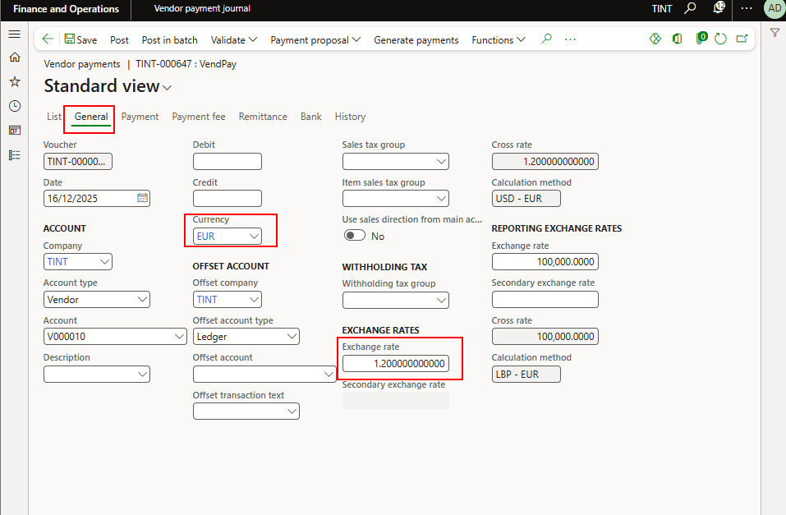

## Foreign currency revaluation

1. Accounts payable > Periodic task > Foreign currency revaluation.
2. Click Simulation to view the revaluation result before processing it.
3. Enter the revaluation vouchers posting date in the Considered date field.
4. Enter exchange rate date in Date of rate field.

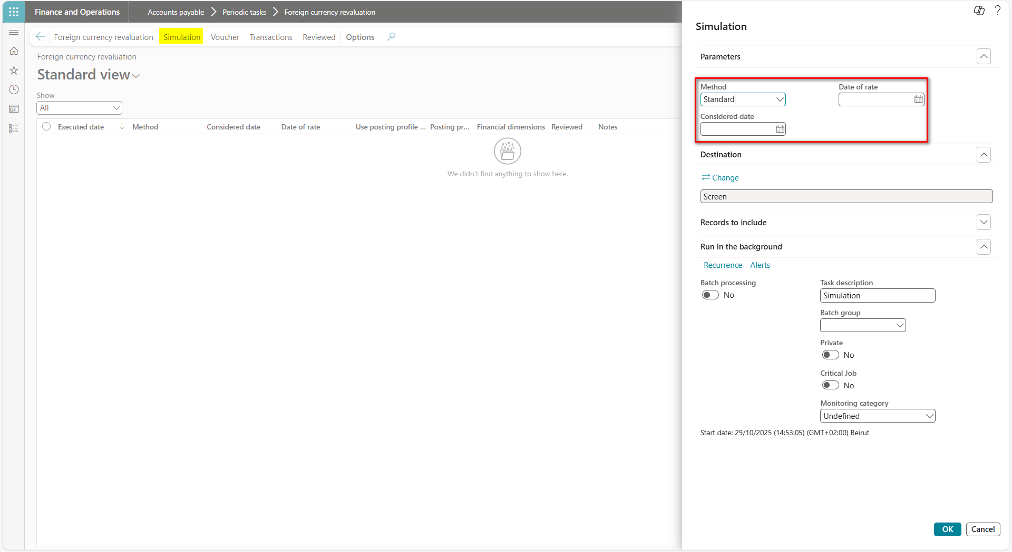

1. Click Ok.

1. Close the report viewer after reviewing it.
2. Click foreign currency revaluation for actual posting.
3. Enter the revaluation vouchers posting date in the Considered date field.
4. Enter exchange rate date in Date of rate field.

1. Click Ok.
2. Click on voucher to review posted voucher.
3. Click reviewed after reviewing the voucher (This will mark the transaction in the reviewed column).

# Accounts payable reports

## Vendor balance inquiry.

* The Vendor Balance Inquiry provides real-time information on the current balances of vendor accounts, including open transactions, settled amounts, and outstanding payables.
* Accounts payable > Vendors > All vendors > Vendor tab > Transactions group > Balance.

## Vendor transactions inquiry.

* The Vendor Transactions Inquiry displays all financial transactions recorded for a specific vendor, such as invoices, payments, credit notes, and settlements.
* Accounts payable > Vendors > All vendors > Vendor tab > Transactions group > Transactions.

## Vendor invoices inquiry.

* The Vendor Inquiry shows all vendor invoices entered in the system, whether open, paid, or pending approval, along with related details such as invoice date, due date, and amount.
* Accounts payable > Vendors > All vendors > Vendor tab > Transactions group > Invoices.

## Vendor transactions report.

* The Vendor Transactions Report summarizes all vendor transactions over a selected period, including invoices, payments, and adjustments.
* Accounts payable > Inquiries and reports > Vendor transactions report.

## Vendor balance list report.

* The Vendor Balance List Report lists vendors with their corresponding balances, showing amounts due and overdue by vendor.
* Accounts payable > Inquiries and reports > Vendor reports > Vendor balance list report.

## Vendor account statement report.

* The Vendor Account Statement Report presents a detailed statement for each vendor, listing all invoices, payments, and adjustments within a defined period.
* Accounts payable > Inquiries and reports > Vendor reports > Account statement report.

## Vendor invoice transactions report.

* The Vendor Invoice Transactions Report provides details of all invoice-related transactions, including invoice numbers, posting dates, amounts, and statuses.
* Accounts payable > Inquiries and reports > Vendor reports > Invoice > Vendor invoice transactions report.

## Vendor aging report.

* The Vendor Aging Report classifies outstanding vendor balances according to aging periods (e.g., 0–30 days, 31–60 days, etc.)
* The aging periods are defined under accounts payable > setup > aging period definition.

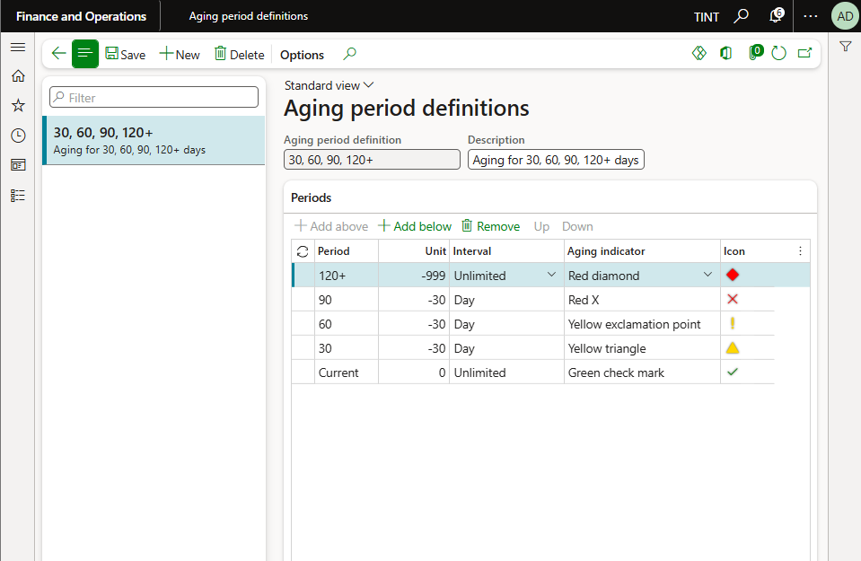

* Accounts payable > Inquiries and reports > Vendor aging report.

